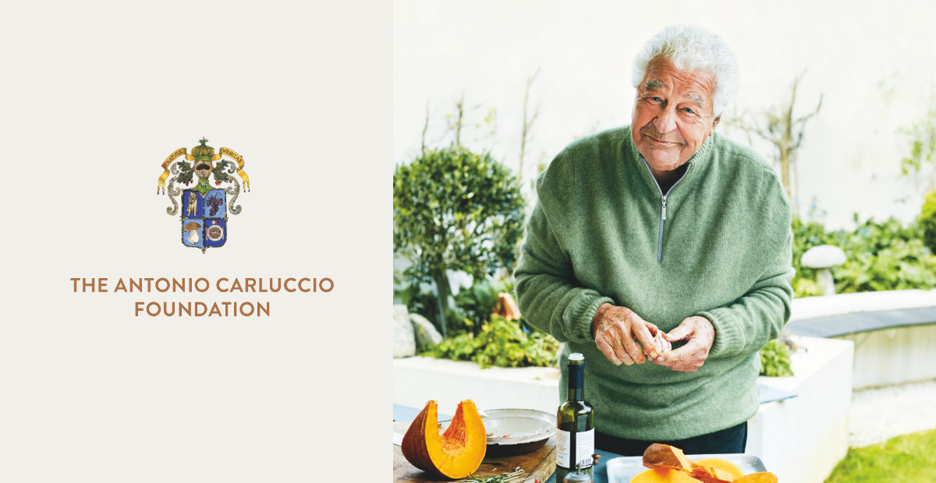

Our Mission – Covid-19 Response
In light of the current crisis, The Antonio Carluccio Foundation is extending its current level of grants for 2020 to £500,000.
Antonio established The Foundation before he died. Amongst his core objectives was the idea to support hospitality related training and development, to promote a better understanding of food origins and nutrition and to make direct support available for organisations working to feed those in need.
Coronavirus makes the need in some of these areas enormous and as a result, we are extending our grants for 2020 to £500,000. Charities working in these areas are invited to apply for grants up to £10,000.
Antonio’s vision was to support organisations worldwide. In the current crisis it is the intention of The Foundation to focus efforts in The United Kingdom and Italy, Antonio’s birth country.

Where and how to send
Apply using the grant application form below. The application should be sent, via email, to trustees@theantoniocarlucciofoundation.org.

The Antonio Carluccio Foundation Grant Application Form

Date of application:
Organisation name:
Registered address:

Key contact details:

Level of grant requested:

Organisation website & social media links:

Are you a registered charity?
If so, please provide your registered charity number:
Are you a non-profit organisation, as defined by Companies House?
If so, please provide your company registration number:
Who are the trustees? Please provide a short 3 line bio for each.

Your organisation
- What is your projected income for the current financial year and your main sources of income?

- Please attach a copy of your most recent report and accounts

- Please confirm that your organisation has up to date policies covering the following:
- Equal Opportunities / Diversity
- Whistle-blowing
- Staff Complain / Grievance Process
- Bullying and Harassment in the Workplace

- Please confirm that your organization records any instances of sexual misconduct involving beneficiaries. Please disclose below how many allegations of sexual misconduct your organization has received in the past 5 years and how they were dealt with. Please attach more information on an additional sheet if necessary.

Please answer all the questions below, ensuring your application does not exceed 1 side of A4.
- What are you trying to do: Describe what your organisation is, and its aims and objectives. Who are your beneficiaries? What are the needs that your organisation will meet and how are you best placed to meet them? Describe your track record of delivering successful projects/initiatives.

- Why are you applying for a grant: Describe how your organisation plans to use the grant and how this will affect your beneficiaries?

Signed: Date:
Job Title

